**Module:1 SDLC**

VANSH PAREKH

1. **What is software? What is software engineering?**

**Ans:** Software is a set of instructions, data or programs used to operate a computer and execute specific tasks. Software engineering is the process of developing computer applications and testing these applications to solve real-world problems by adhering to a set of engineering principles and best practices.

**2)Explain types of software.**

**Ans:** The following are the Main types of software.

1. System software: It is a type of computer program that is designed to run a computer’s hardware and application programs.

2. Application software: It is a computer program that performs a specific personal, educational, and business function.

3. Programming software: It is a tool for creating a computer code that allows computer software to operate.

**3)What is SDLC? Explain each phase of SDLC.**

**Ans:** The SDLC- Software development lifecycle is a cost-efficient and time-efficient process that development teams use to design and build high-quality software.

The detailed SDLC process varies but a mandatory phase below.

1. Plan - The planning phase typically includes tasks like cost-benefits analysis, scheduling, resource, estimation and allocation.
2. Design - Software engineers analyze requirements and identify the best solutions to create software.
3. Implementation - The developer codes the product daily. According to the requirements of the client, the developer tries to code the software.
4. Testing - The developer combines automation and manual testing to check the software for bugs. The quality analysis includes testing the software for errors and checking if it meets client requirements.
5. Deploy - While the software is developing, the software that the client uses is called “*production”,* while other copies are said to be in the “*build environment”.*
6. *.* Maintain - In the maintenance phase, among other tasks, the developer fixes bugs, resolves customer issues and manages software changes. It also monitors overall system performance, security, and user experience to identify new ways to improve the existing software.

**4) What is DFD? Create a DFD diagram for Flipkart?**

**Ans:** A **Data Flow Diagram** (DFD) is a visual tool that shows how information moves through a system. AS a map that outline:

* **Where data comes from**(inputs)
* **Where data goes**(output)
* **How data is processed** within the system
* **Where data is stored**

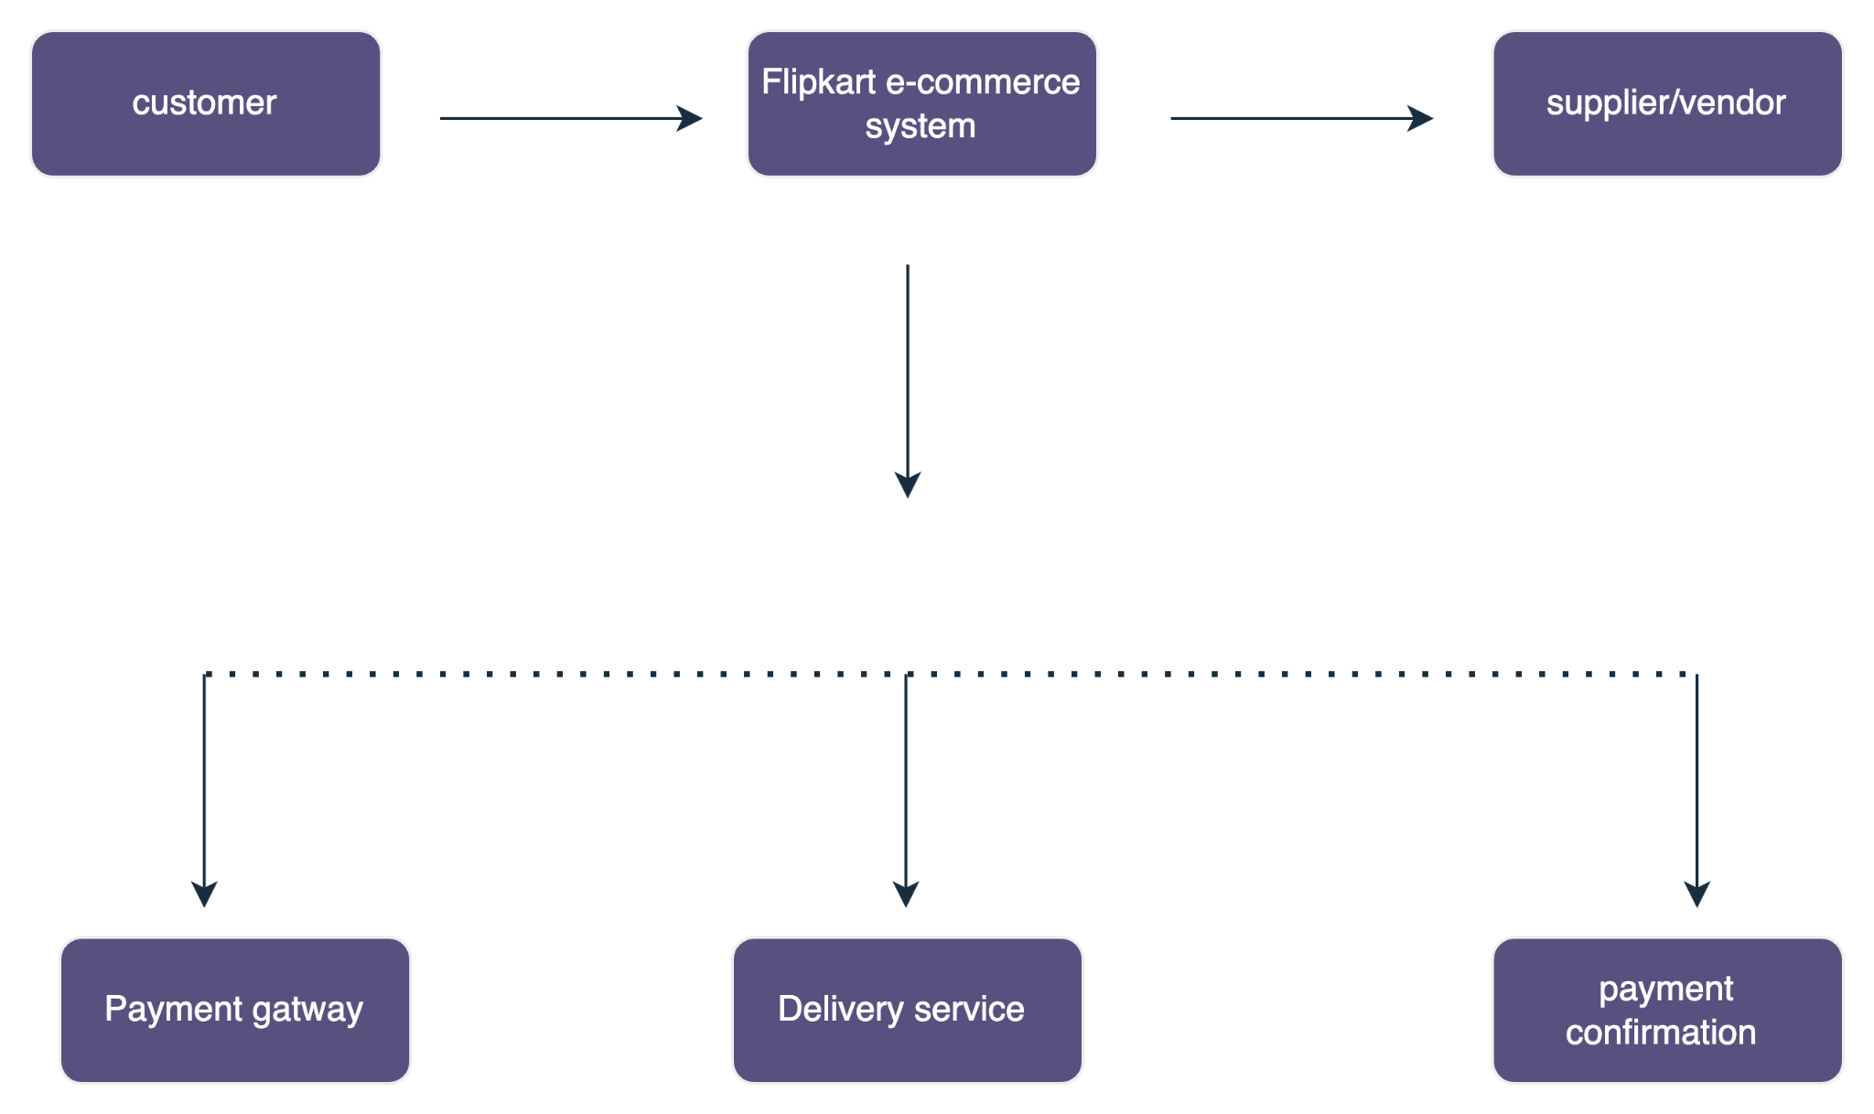

**5) What is Flowchart? Create a flowchart to make addition of two number.**

**Ans:** A Flowchart is a simple diagram that shows the steps of process or how something works. It is likea map that helps you understand the path or actions needed to complete a task.

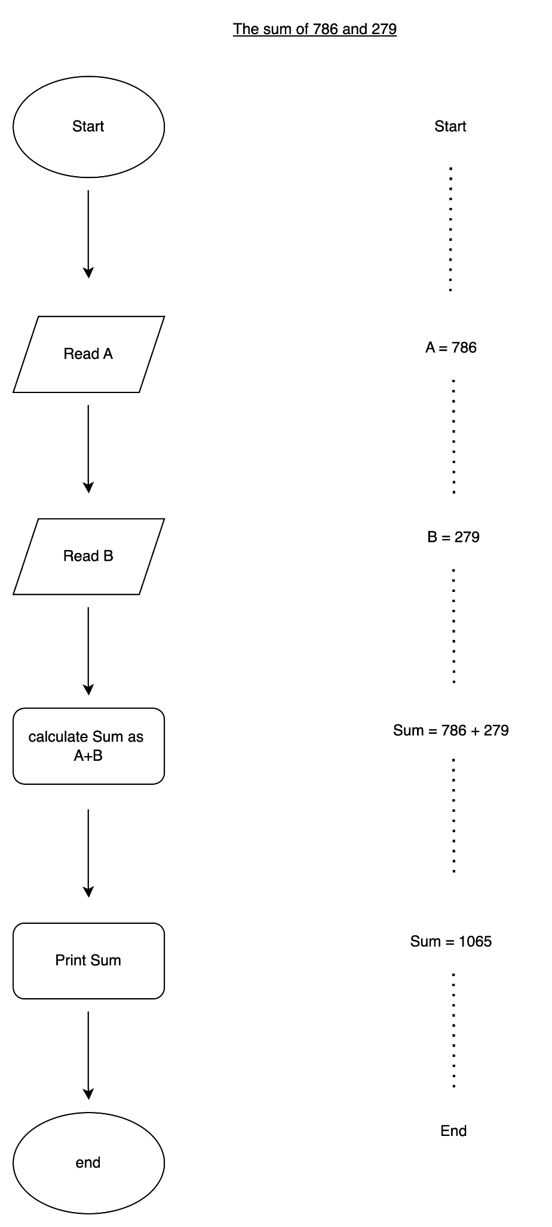

**6) what is Use case Diagram? Create a use case on bill on Paypal.**

**Ans:** A Use case Diagram shows how a system works abd who uses it. It shows what people can do with system, like logging in, making payments, etc. It helps everyone understand with the system does without going into too much detail.

